The admin link in your email does not work.
Admin Credential:
URL: https://payperdialog.com/admin/
Email address: test@gmail.com
Password: 123456

I signed in as the employer.
On the profile, we can avoid saying candidate “…what differentiates you as a candidate”
- For Employer text changed to “Please let us know about you”, for employee text will remain same “Please let us know what differentiates you as a candidate”
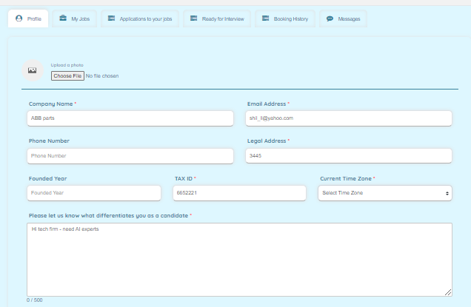
On clicking booking history, I see this, which is not what was intended: Fixed
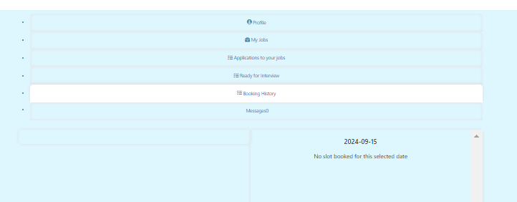

Also, can we change the term “booking history” to “meetings scheduled” Fixed

The “messages” tab can be removed and can be a link within the “ready for interview” tab against each candidate selected.

The search function does not work:
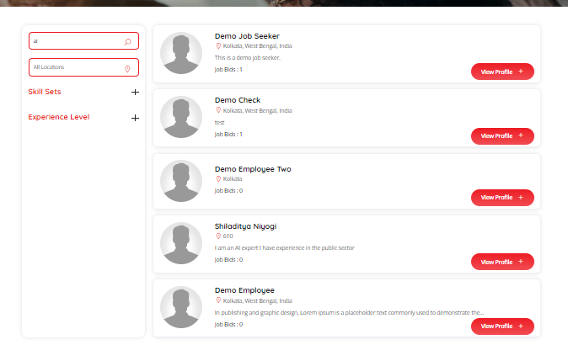
When I inserted ai and searched
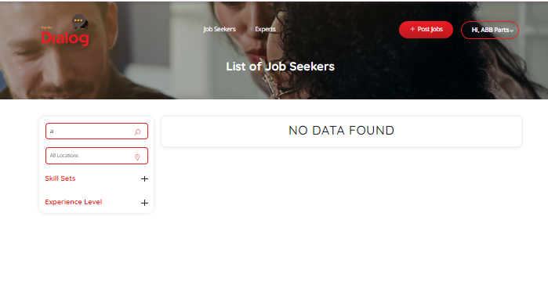
Also the skill sets does not let me enter anything or select from a list Search function fixed.
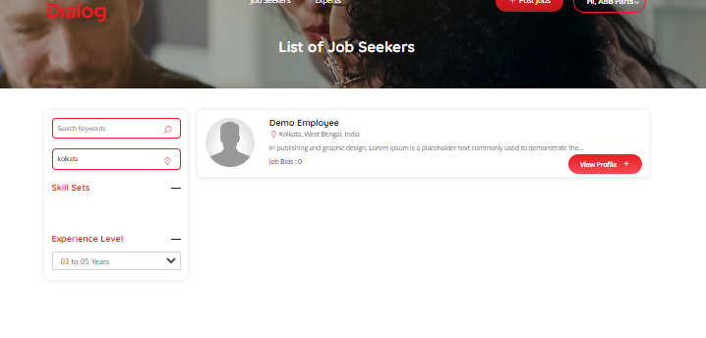

Some of the elements are not needed
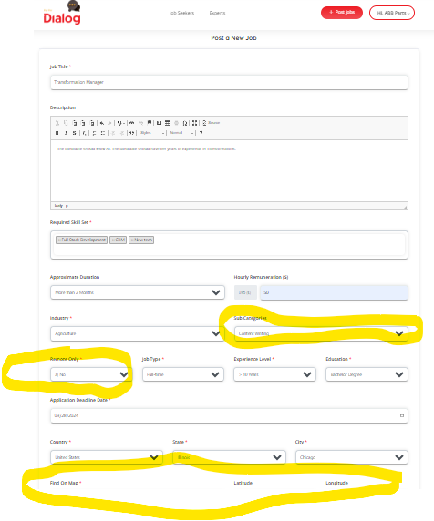
Subcategory is not needed Removed subcategory from the from
There is no need of approximate duration field. We can instead say permanent or contract.
Modified as per requirement
If someone selects Remote only then the location of the job (State, City) are not needed. The other options can be Hybrid and On site, along with Remote. Modified as per requirement
The Find on Map can be optional (It can take City, State, if address is not entered). Also all the fields on map box gets grayed out if the work is remote. Modified as per requirement
--
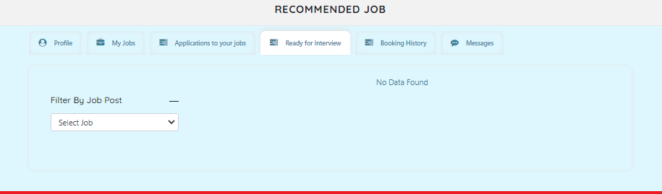
Under “ready for interview” The filter by job post does not show any job though I have two jobs create

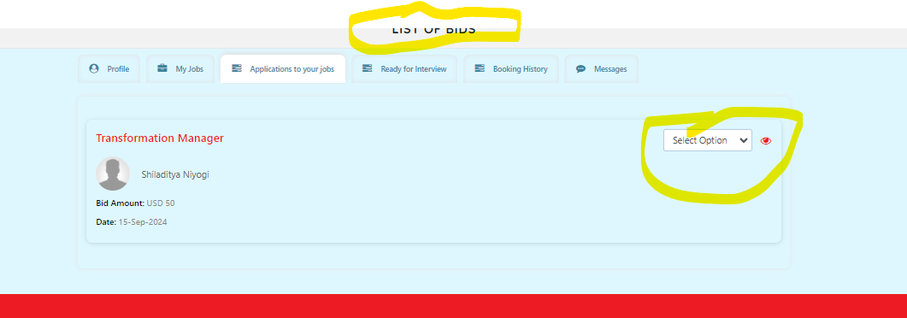
“List of Bids” can be replaced by “Job Applicants”
Also options can be limited to Screened Out, and Ready for interview. “Ready for Interview” will open up the messaging option. Please remove the Screening in stage.

When I selected Ready for Interview and tried to filter by job post and clicked on the relevant job it didn’t show me the applicant.
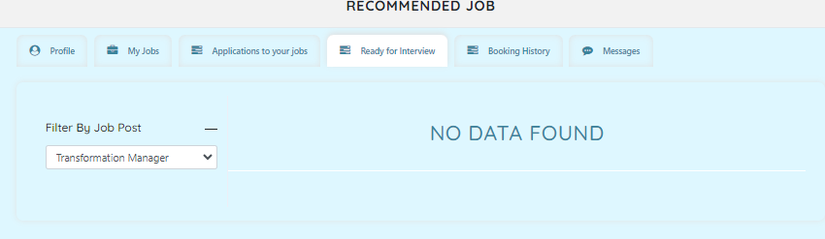
However, I didn’t select the job and could see the applicant
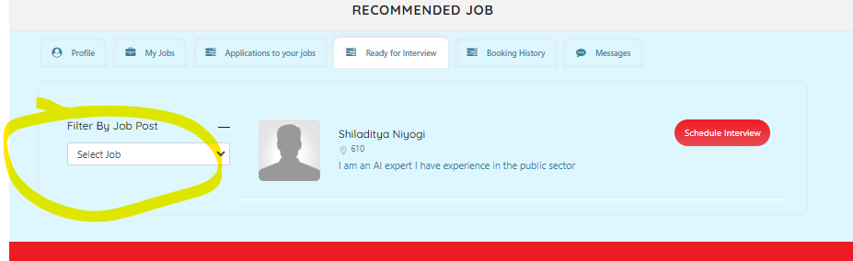

When I clicked on schedule interview button, a completely different screen came up.

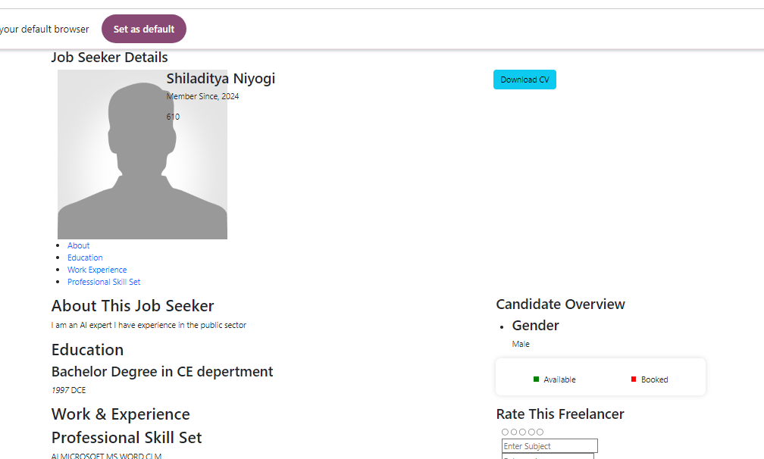

It doesn’t let me schedule. So, I cannot interview. Major bug
The messages are also gone – so I cannot reach the candidate anymore.
If we remove the screening in option and put messaging link against every candidate then that will help this use case.
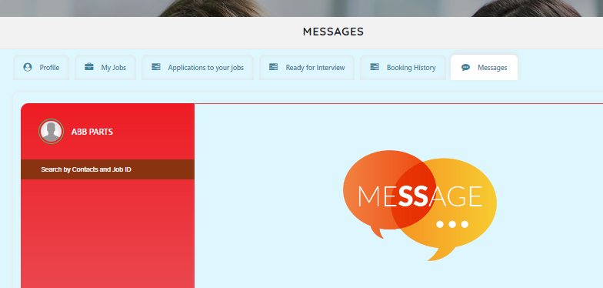

EMPLOYEE
I signed up as an employee then
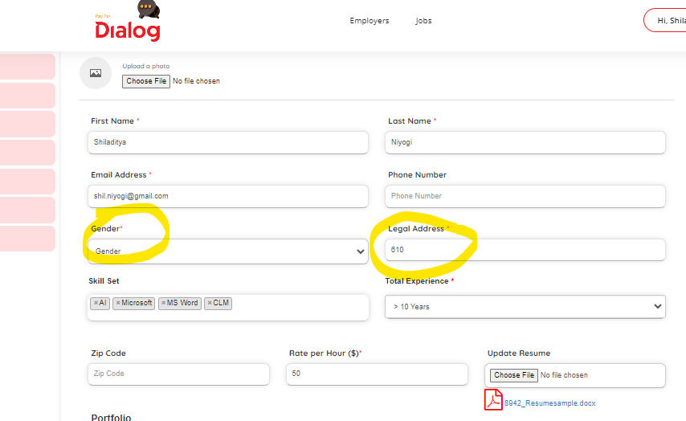
Can you please add “Non Binary” in the options.

Also don’t call it Legal Address – please say just address and make it non mandatory.
Also add City, State.

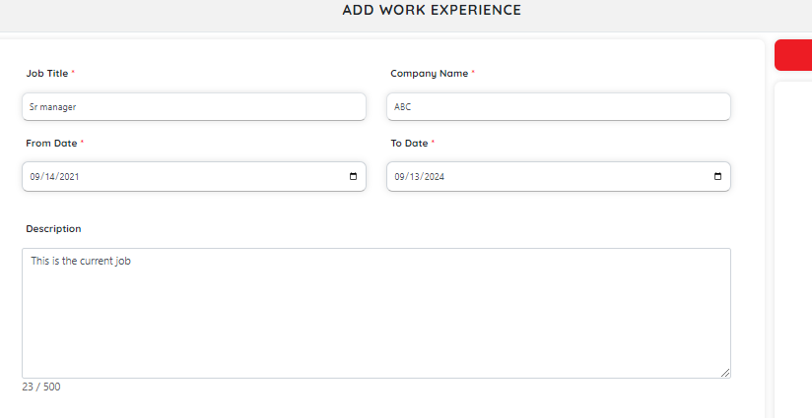

In Work experience there should be a check box for “current employer”

--
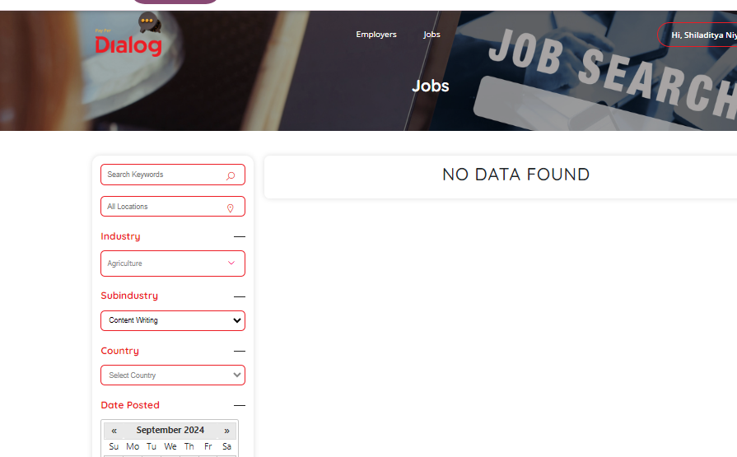
When I search for jobs, on selecting a location it doesn’t show me the job.
Also, Date posted can have these options:
“less than a week ago”
“less than a month ago”
“less than 3 months ago"
“more than 3 months ago"

--
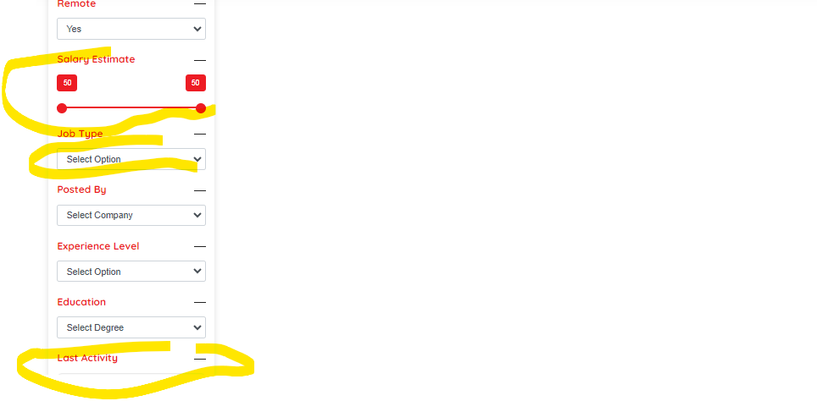
Salary estimate can be a number line (yearly salary can be between 0 and $1 million, if a person chooses full time or it can be an hourly rate from 0 to $1000)
Job Type can be Full time or Contract

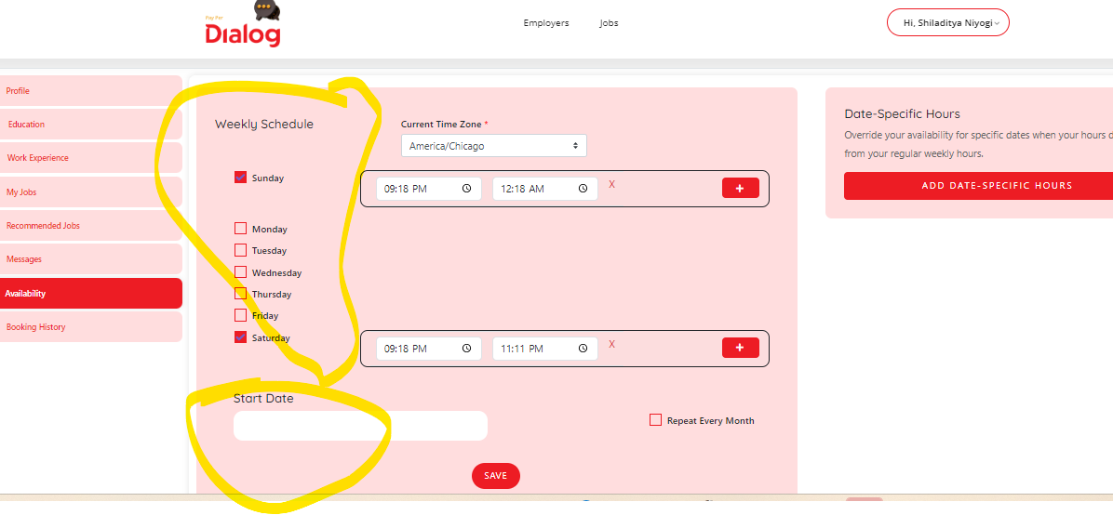
For some reason the Start date is not displaying the current date.
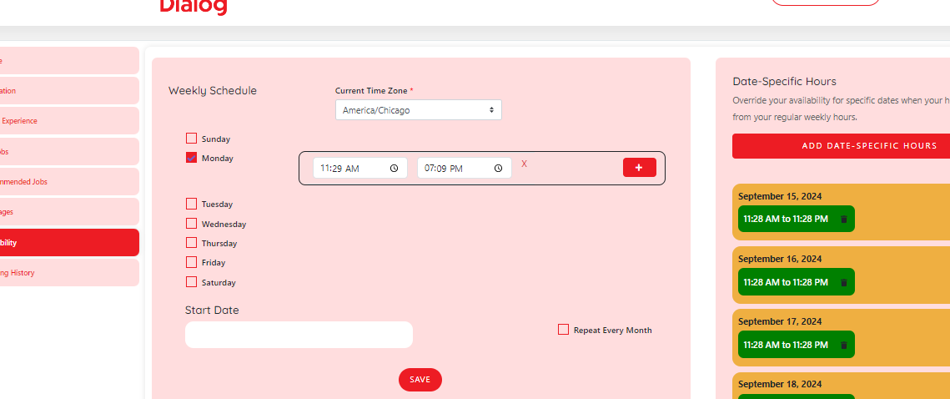
I used the other method.

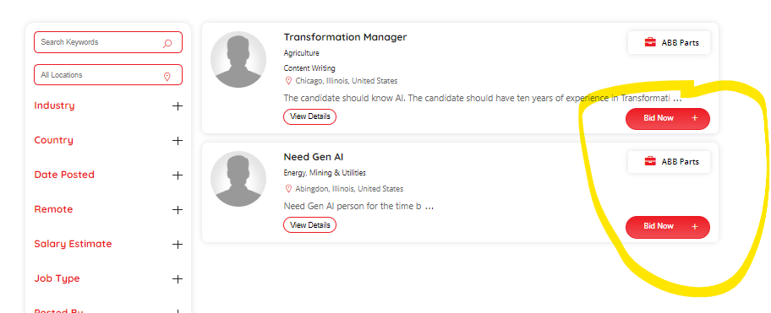

For applying, please replace “Bid now” by “ Apply”

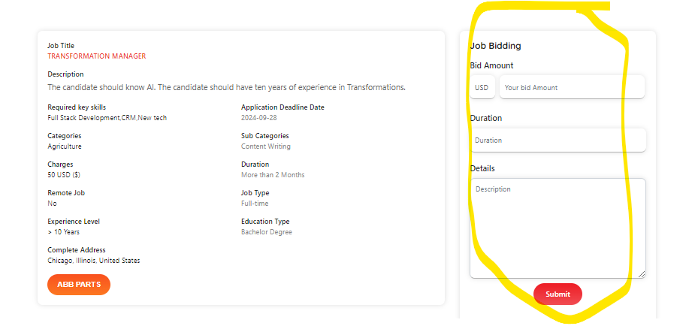
There should be no job bidding for a job. There should be a button “Apply”

